Aula04 – Navegando entre Telas – NetBeams. FORMULÁRIO DE CADASTRO

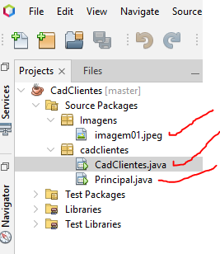

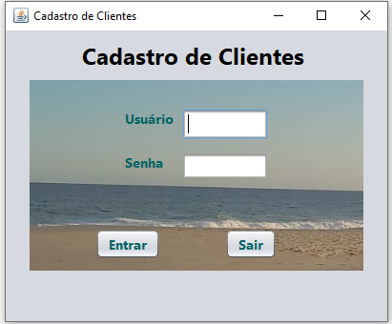

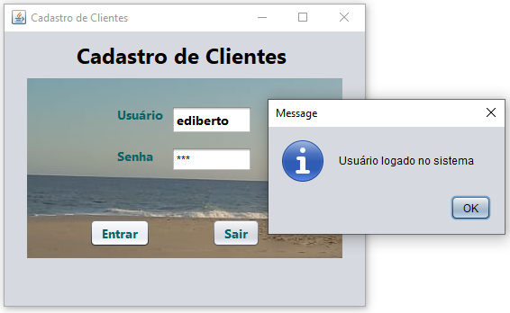

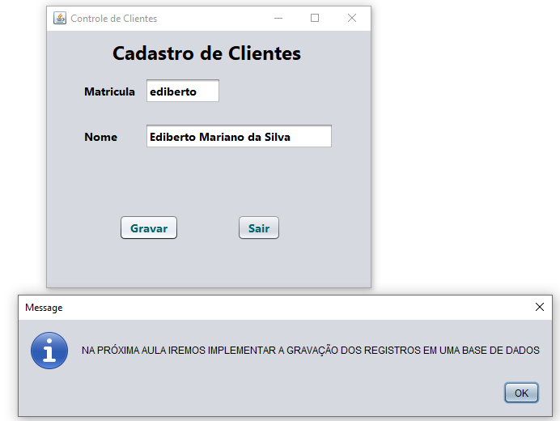

**CadClientes.java**

package cadclientes;

import javax.swing.JOptionPane;

public class CadClientes extends javax.swing.JFrame {

public CadClientes() {

initComponents();

}

@SuppressWarnings("unchecked")

// <editor-fold defaultstate="collapsed" desc="Generated Code">

private void initComponents() {

jLabel2 = new javax.swing.JLabel();

jLabel1 = new javax.swing.JLabel();

txtusuario = new javax.swing.JFormattedTextField();

txtsenha = new javax.swing.JPasswordField();

jLabel3 = new javax.swing.JLabel();

txtBotaoEntrar = new javax.swing.JButton();

txtBotaoSair = new javax.swing.JButton();

jLabel4 = new javax.swing.JLabel();

setDefaultCloseOperation(javax.swing.WindowConstants.DISPOSE_ON_CLOSE);

setTitle("Cadastro de Clientes");

jLabel2.setBackground(new java.awt.Color(204, 255, 204));

jLabel2.setFont(new java.awt.Font("Segoe UI", 1, 24)); // NOI18N

jLabel2.setText("Cadastro de Clientes");

jLabel1.setFont(new java.awt.Font("Segoe UI", 1, 14)); // NOI18N

jLabel1.setForeground(new java.awt.Color(0, 102, 102));

jLabel1.setText("Usuário");

txtusuario.setFont(new java.awt.Font("Segoe UI", 1, 14)); // NOI18N

txtusuario.addActionListener(new java.awt.event.ActionListener() {

public void actionPerformed(java.awt.event.ActionEvent evt) {

txtusuarioActionPerformed(evt);

}

});

jLabel3.setFont(new java.awt.Font("Segoe UI", 1, 14)); // NOI18N

jLabel3.setForeground(new java.awt.Color(0, 102, 102));

jLabel3.setText("Senha");

txtBotaoEntrar.setFont(new java.awt.Font("Segoe UI", 1, 14)); // NOI18N

txtBotaoEntrar.setForeground(new java.awt.Color(0, 102, 102));

txtBotaoEntrar.setText("Entrar");

txtBotaoEntrar.addActionListener(new java.awt.event.ActionListener() {

public void actionPerformed(java.awt.event.ActionEvent evt) {

txtBotaoEntrarActionPerformed(evt);

}

});

txtBotaoSair.setFont(new java.awt.Font("Segoe UI", 1, 14)); // NOI18N

txtBotaoSair.setForeground(new java.awt.Color(0, 102, 102));

txtBotaoSair.setText("Sair");

txtBotaoSair.addActionListener(new java.awt.event.ActionListener() {

public void actionPerformed(java.awt.event.ActionEvent evt) {

txtBotaoSairActionPerformed(evt);

}

});

jLabel4.setIcon(new javax.swing.ImageIcon(getClass().getResource("/Imagens/imagem01.jpeg"))); // NOI18N

javax.swing.GroupLayout layout = new javax.swing.GroupLayout(getContentPane());

getContentPane().setLayout(layout);

layout.setHorizontalGroup(

layout.createParallelGroup(javax.swing.GroupLayout.Alignment.LEADING)

.addGroup(layout.createSequentialGroup()

.addGroup(layout.createParallelGroup(javax.swing.GroupLayout.Alignment.LEADING)

.addGroup(layout.createSequentialGroup()

.addGap(80, 80, 80)

.addComponent(jLabel2, javax.swing.GroupLayout.PREFERRED_SIZE, 240, javax.swing.GroupLayout.PREFERRED_SIZE))

.addGroup(layout.createSequentialGroup()

.addGap(94, 94, 94)

.addComponent(txtBotaoEntrar)

.addGap(68, 68, 68)

.addComponent(txtBotaoSair)))

.addContainerGap(80, Short.MAX_VALUE))

.addGroup(layout.createParallelGroup(javax.swing.GroupLayout.Alignment.LEADING)

.addGroup(layout.createSequentialGroup()

.addGap(0, 0, Short.MAX_VALUE)

.addGroup(layout.createParallelGroup(javax.swing.GroupLayout.Alignment.LEADING)

.addGroup(layout.createSequentialGroup()

.addGap(100, 100, 100)

.addComponent(jLabel1, javax.swing.GroupLayout.PREFERRED_SIZE, 60, javax.swing.GroupLayout.PREFERRED_SIZE)

.addGap(0, 0, 0)

.addComponent(txtusuario, javax.swing.GroupLayout.PREFERRED_SIZE, 90, javax.swing.GroupLayout.PREFERRED_SIZE))

.addGroup(layout.createSequentialGroup()

.addGap(100, 100, 100)

.addComponent(jLabel3, javax.swing.GroupLayout.PREFERRED_SIZE, 50, javax.swing.GroupLayout.PREFERRED_SIZE)

.addGap(10, 10, 10)

.addComponent(txtsenha, javax.swing.GroupLayout.PREFERRED_SIZE, 90, javax.swing.GroupLayout.PREFERRED_SIZE))

.addComponent(jLabel4, javax.swing.GroupLayout.PREFERRED_SIZE, 350, javax.swing.GroupLayout.PREFERRED_SIZE))

.addGap(0, 0, Short.MAX_VALUE)))

);

layout.setVerticalGroup(

layout.createParallelGroup(javax.swing.GroupLayout.Alignment.LEADING)

.addGroup(layout.createSequentialGroup()

.addContainerGap()

.addComponent(jLabel2, javax.swing.GroupLayout.PREFERRED_SIZE, 40, javax.swing.GroupLayout.PREFERRED_SIZE)

.addPreferredGap(javax.swing.LayoutStyle.ComponentPlacement.RELATED, 162, Short.MAX_VALUE)

.addGroup(layout.createParallelGroup(javax.swing.GroupLayout.Alignment.LEADING)

.addComponent(txtBotaoEntrar)

.addComponent(txtBotaoSair))

.addGap(65, 65, 65))

.addGroup(layout.createParallelGroup(javax.swing.GroupLayout.Alignment.LEADING)

.addGroup(layout.createSequentialGroup()

.addGap(0, 0, Short.MAX_VALUE)

.addGroup(layout.createParallelGroup(javax.swing.GroupLayout.Alignment.LEADING)

.addGroup(layout.createSequentialGroup()

.addGap(30, 30, 30)

.addGroup(layout.createParallelGroup(javax.swing.GroupLayout.Alignment.LEADING)

.addComponent(jLabel1)

.addComponent(txtusuario, javax.swing.GroupLayout.PREFERRED_SIZE, javax.swing.GroupLayout.DEFAULT_SIZE, javax.swing.GroupLayout.PREFERRED_SIZE))

.addGap(14, 14, 14)

.addGroup(layout.createParallelGroup(javax.swing.GroupLayout.Alignment.LEADING)

.addComponent(jLabel3)

.addComponent(txtsenha, javax.swing.GroupLayout.PREFERRED_SIZE, javax.swing.GroupLayout.DEFAULT_SIZE, javax.swing.GroupLayout.PREFERRED_SIZE)))

.addComponent(jLabel4, javax.swing.GroupLayout.PREFERRED_SIZE, 200, javax.swing.GroupLayout.PREFERRED_SIZE))

.addGap(0, 0, Short.MAX_VALUE)))

);

pack();

setLocationRelativeTo(null);

}// </editor-fold>

private void txtusuarioActionPerformed(java.awt.event.ActionEvent evt) {

// TODO add your handling code here:

}

private void txtBotaoEntrarActionPerformed(java.awt.event.ActionEvent evt) {

// EVENTO ONCLICK DO BOTÃO ENTRAR

/*String username = txtusuario.getText().toLowerCase(); // Converter para letras minúsculas

String password = new String(txtsenha.getPassword());

if (username.equals("ediberto") && password.equals("123")) {

JOptionPane.showMessageDialog(null, "Usuário logado no sistema");

// Código para abrir a Tela Principal

Principal principal = new Principal();

principal.setVisible(true);

// Fechar a tela de CadClientes (se necessário)

dispose();

} else {

JOptionPane.showMessageDialog(null, "Usuário e/ou senha inválidos");

} */

//OU ASSIM

if(txtusuario.getText().equals("ediberto") && new String(txtsenha.getPassword()).equals("123")){

JOptionPane.showMessageDialog(null, "Usuário logado no sistema");

// Código para abrir a Tela Principal

Principal principal = new Principal();

principal.setVisible(true);

// Fechar a tela de CadClientes (se necessário)

dispose();

} else {

JOptionPane.showMessageDialog(null, "Usuário e/ou senha inválidos");

}

}

private void txtBotaoSairActionPerformed(java.awt.event.ActionEvent evt) {

// SAIR DO SISTEMA

this.dispose(); // Fecha a janela atual

JOptionPane.showMessageDialog(null, "SISTEMA FECHADO!!!");

}

public static void main(String args[]) {

try {

for (javax.swing.UIManager.LookAndFeelInfo info : javax.swing.UIManager.getInstalledLookAndFeels()) {

if ("Nimbus".equals(info.getName())) {

javax.swing.UIManager.setLookAndFeel(info.getClassName());

break;

}

}

} catch (ClassNotFoundException ex) {

java.util.logging.Logger.getLogger(CadClientes.class.getName()).log(java.util.logging.Level.SEVERE, null, ex);

} catch (InstantiationException ex) {

java.util.logging.Logger.getLogger(CadClientes.class.getName()).log(java.util.logging.Level.SEVERE, null, ex);

} catch (IllegalAccessException ex) {

java.util.logging.Logger.getLogger(CadClientes.class.getName()).log(java.util.logging.Level.SEVERE, null, ex);

} catch (javax.swing.UnsupportedLookAndFeelException ex) {

java.util.logging.Logger.getLogger(CadClientes.class.getName()).log(java.util.logging.Level.SEVERE, null, ex);

}

//</editor-fold>

/* Create and display the form */

java.awt.EventQueue.invokeLater(new Runnable() {

public void run() {

new CadClientes().setVisible(true);

}

});

}

// Variables declaration - do not modify

private javax.swing.JLabel jLabel1;

private javax.swing.JLabel jLabel2;

private javax.swing.JLabel jLabel3;

private javax.swing.JLabel jLabel4;

private javax.swing.JButton txtBotaoEntrar;

private javax.swing.JButton txtBotaoSair;

private javax.swing.JPasswordField txtsenha;

private javax.swing.JFormattedTextField txtusuario;

}

**Principal.java**

package cadclientes;

import javax.swing.JOptionPane;

public class Principal extends javax.swing.JFrame {

public Principal() {

initComponents();

}

@SuppressWarnings("unchecked")

// <editor-fold defaultstate="collapsed" desc="Generated Code">

private void initComponents() {

jLabel2 = new javax.swing.JLabel();

jLabel1 = new javax.swing.JLabel();

txtMat = new javax.swing.JTextField();

jLabel3 = new javax.swing.JLabel();

txtNome = new javax.swing.JTextField();

btnGravar = new javax.swing.JButton();

btnSair = new javax.swing.JButton();

setDefaultCloseOperation(javax.swing.WindowConstants.DISPOSE_ON_CLOSE);

setTitle("Controle de Clientes");

jLabel2.setBackground(new java.awt.Color(204, 255, 204));

jLabel2.setFont(new java.awt.Font("Segoe UI", 1, 24)); // NOI18N

jLabel2.setText("Cadastro de Clientes");

jLabel1.setFont(new java.awt.Font("Segoe UI", 1, 14)); // NOI18N

jLabel1.setText("Matricula");

txtMat.setFont(new java.awt.Font("Segoe UI", 1, 14)); // NOI18N

jLabel3.setFont(new java.awt.Font("Segoe UI", 1, 14)); // NOI18N

jLabel3.setText("Nome");

txtNome.setFont(new java.awt.Font("Segoe UI", 1, 14)); // NOI18N

txtNome.addActionListener(new java.awt.event.ActionListener() {

public void actionPerformed(java.awt.event.ActionEvent evt) {

txtNomeActionPerformed(evt);

}

});

btnGravar.setFont(new java.awt.Font("Segoe UI", 1, 14)); // NOI18N

btnGravar.setForeground(new java.awt.Color(0, 102, 102));

btnGravar.setText("Gravar");

btnGravar.addActionListener(new java.awt.event.ActionListener() {

public void actionPerformed(java.awt.event.ActionEvent evt) {

btnGravarActionPerformed(evt);

}

});

btnSair.setFont(new java.awt.Font("Segoe UI", 1, 14)); // NOI18N

btnSair.setForeground(new java.awt.Color(0, 102, 102));

btnSair.setText("Sair");

btnSair.addActionListener(new java.awt.event.ActionListener() {

public void actionPerformed(java.awt.event.ActionEvent evt) {

btnSairActionPerformed(evt);

}

});

javax.swing.GroupLayout layout = new javax.swing.GroupLayout(getContentPane());

getContentPane().setLayout(layout);

layout.setHorizontalGroup(

layout.createParallelGroup(javax.swing.GroupLayout.Alignment.LEADING)

.addGroup(javax.swing.GroupLayout.Alignment.TRAILING, layout.createSequentialGroup()

.addContainerGap(javax.swing.GroupLayout.DEFAULT_SIZE, Short.MAX_VALUE)

.addComponent(jLabel2, javax.swing.GroupLayout.PREFERRED_SIZE, 240, javax.swing.GroupLayout.PREFERRED_SIZE)

.addGap(79, 79, 79))

.addGroup(layout.createSequentialGroup()

.addGroup(layout.createParallelGroup(javax.swing.GroupLayout.Alignment.LEADING)

.addGroup(layout.createSequentialGroup()

.addGap(46, 46, 46)

.addGroup(layout.createParallelGroup(javax.swing.GroupLayout.Alignment.LEADING)

.addComponent(jLabel1)

.addComponent(jLabel3))

.addPreferredGap(javax.swing.LayoutStyle.ComponentPlacement.UNRELATED)

.addGroup(layout.createParallelGroup(javax.swing.GroupLayout.Alignment.LEADING)

.addComponent(txtNome, javax.swing.GroupLayout.PREFERRED_SIZE, 233, javax.swing.GroupLayout.PREFERRED_SIZE)

.addComponent(txtMat, javax.swing.GroupLayout.PREFERRED_SIZE, 94, javax.swing.GroupLayout.PREFERRED_SIZE)))

.addGroup(layout.createSequentialGroup()

.addGap(89, 89, 89)

.addComponent(btnGravar)

.addGap(72, 72, 72)

.addComponent(btnSair)))

.addContainerGap(46, Short.MAX_VALUE))

);

layout.setVerticalGroup(

layout.createParallelGroup(javax.swing.GroupLayout.Alignment.LEADING)

.addGroup(layout.createSequentialGroup()

.addContainerGap()

.addComponent(jLabel2, javax.swing.GroupLayout.PREFERRED_SIZE, 40, javax.swing.GroupLayout.PREFERRED_SIZE)

.addPreferredGap(javax.swing.LayoutStyle.ComponentPlacement.UNRELATED)

.addGroup(layout.createParallelGroup(javax.swing.GroupLayout.Alignment.BASELINE)

.addComponent(jLabel1)

.addComponent(txtMat, javax.swing.GroupLayout.PREFERRED_SIZE, javax.swing.GroupLayout.DEFAULT_SIZE, javax.swing.GroupLayout.PREFERRED_SIZE))

.addGap(24, 24, 24)

.addGroup(layout.createParallelGroup(javax.swing.GroupLayout.Alignment.BASELINE)

.addComponent(jLabel3)

.addComponent(txtNome, javax.swing.GroupLayout.PREFERRED_SIZE, javax.swing.GroupLayout.DEFAULT_SIZE, javax.swing.GroupLayout.PREFERRED_SIZE))

.addPreferredGap(javax.swing.LayoutStyle.ComponentPlacement.RELATED, 81, Short.MAX_VALUE)

.addGroup(layout.createParallelGroup(javax.swing.GroupLayout.Alignment.BASELINE)

.addComponent(btnGravar)

.addComponent(btnSair))

.addGap(58, 58, 58))

);

pack();

setLocationRelativeTo(null);

}// </editor-fold>

private void txtNomeActionPerformed(java.awt.event.ActionEvent evt) {

// TODO add your handling code here:

}

private void btnGravarActionPerformed(java.awt.event.ActionEvent evt) {

JOptionPane.showMessageDialog(null, "NA PRÓXIMA AULA IREMOS IMPLEMENTAR A GRAVAÇÃO DOS REGISTROS EM UMA BASE DE DADOS");

}

private void btnSairActionPerformed(java.awt.event.ActionEvent evt) {

// Fechar a tela de CadClientes (se necessário)

dispose();

CadClientes cadclientes = new CadClientes();

cadclientes.setVisible(true);

}

public static void main(String args[]) {

try {

for (javax.swing.UIManager.LookAndFeelInfo info : javax.swing.UIManager.getInstalledLookAndFeels()) {

if ("Nimbus".equals(info.getName())) {

javax.swing.UIManager.setLookAndFeel(info.getClassName());

break;

}

}

} catch (ClassNotFoundException ex) {

java.util.logging.Logger.getLogger(Principal.class.getName()).log(java.util.logging.Level.SEVERE, null, ex);

} catch (InstantiationException ex) {

java.util.logging.Logger.getLogger(Principal.class.getName()).log(java.util.logging.Level.SEVERE, null, ex);

} catch (IllegalAccessException ex) {

java.util.logging.Logger.getLogger(Principal.class.getName()).log(java.util.logging.Level.SEVERE, null, ex);

} catch (javax.swing.UnsupportedLookAndFeelException ex) {

java.util.logging.Logger.getLogger(Principal.class.getName()).log(java.util.logging.Level.SEVERE, null, ex);

}

java.awt.EventQueue.invokeLater(new Runnable() {

public void run() {

new Principal().setVisible(true);

}

});

}

private javax.swing.JButton btnGravar;

private javax.swing.JButton btnSair;

private javax.swing.JLabel jLabel1;

private javax.swing.JLabel jLabel2;

private javax.swing.JLabel jLabel3;

private javax.swing.JTextField txtMat;

private javax.swing.JTextField txtNome;

}